The Alliance for Sustainable Communities: Mercer Monmouth (TASC) Factsheet on Mercer Corporate Park
Who? A warehouse proposal by Spartanburg, SC Johnson Development, LLC
What? Construction of 500,000 square feet of warehouse and accompanying parking areas which would cover nearly 50 percent of the 90-acre site with impervious surfaces along with the daily addition of 250 truck and 400 car trips to local roadways.
Where?
Mercer Corporate Park – This 90 acre tract is NOT located in the Robbinsville Matrix Warehouse Park but is totally separate from that location.
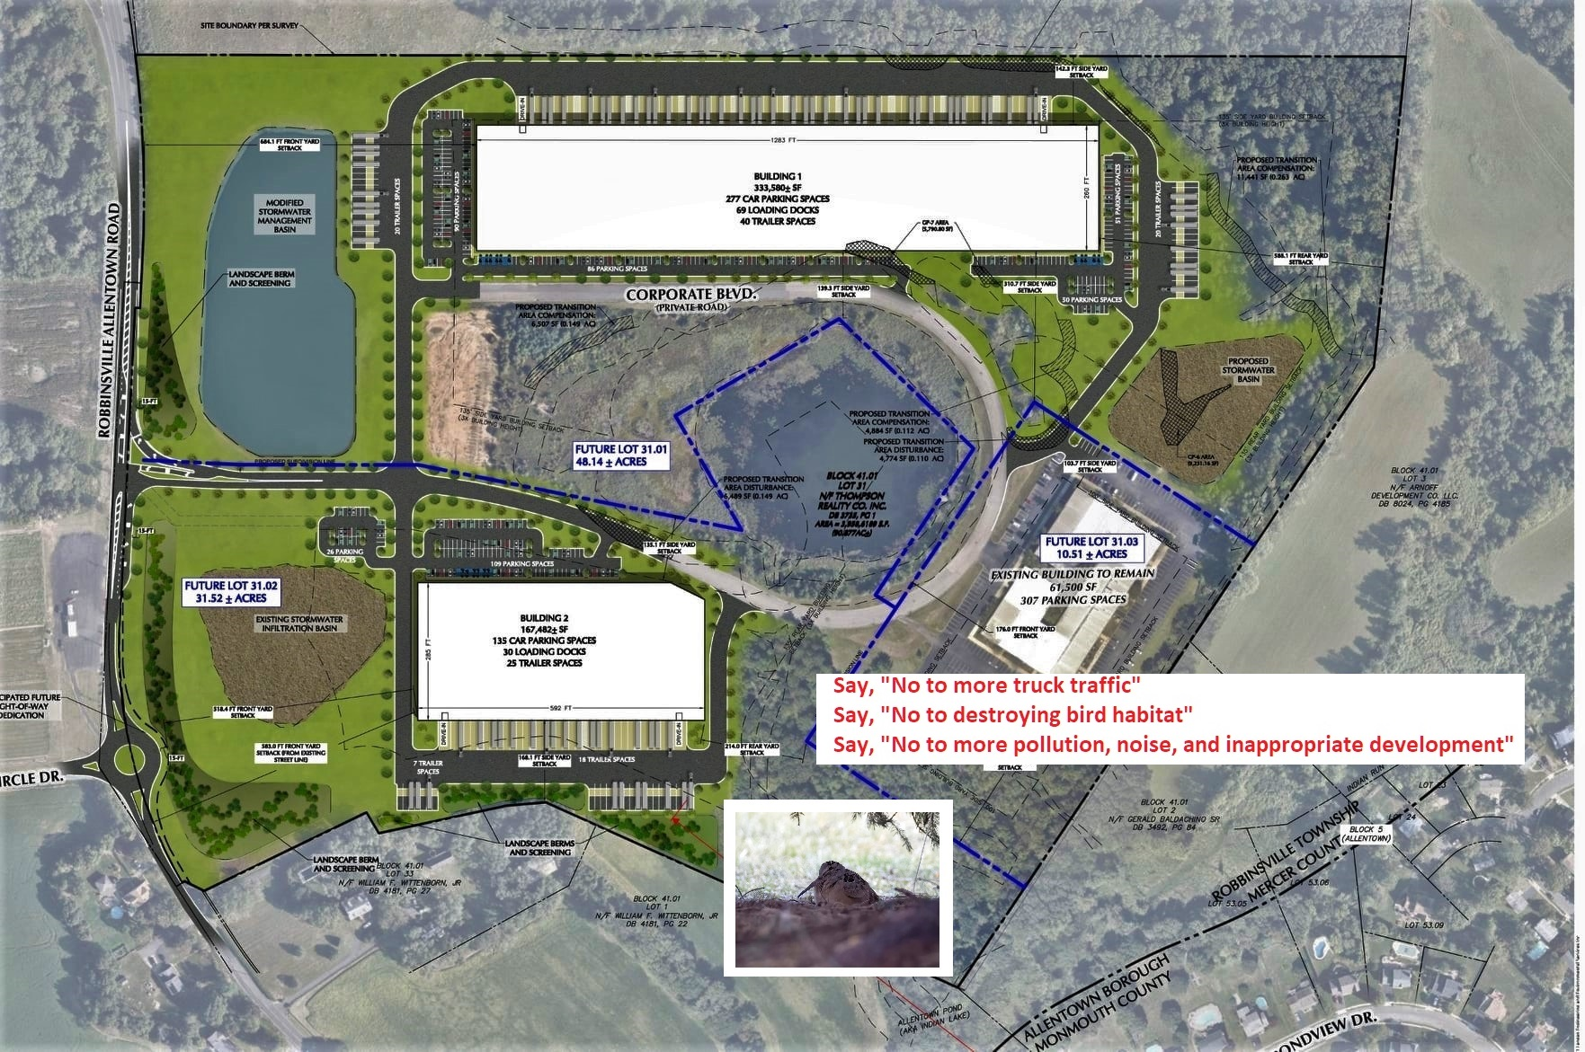

Why Does this matter?
- Addition of 250 truck and 400 car trips to local roadways which include an incomplete interstate exit, insufficient County roadway, and Historic Allentown with its narrow, residential streets and failing intersections
- Damage to local infrastructure
- Destruction of one of New Jersey’s top birding “hotspots” where nearly 200 bird species have been observed as well as numerous documented threatened and endangered species.
- Noise and air pollution
- Increased stormwater runoff and flooding of downstream properties
- Decreased residential property values
- Inappropriate development of an area where millions of dollars of municipal and county open space funding have already purchased scores of acres of land
What can you do?
- Attend the Tuesday, December 6th at 7 pm site plan hearing (at Robbinsville Municipal Building on Route 33) for this warehouse proposal and speak out against this proposal.
- Please check the Robbinsville Twp website for any changes at: https://www.robbinsville-twp.org/departments/planning_and_zoning/meeting_exhibits.php
- Sign the online petition opposing this incompatible and inappropriate proposal at. https://www.change.org/TASCTogether
- Join the TASC Facebook group
- Communicate your contact information and ideas to: TASC1@googlegroups.com
- Write Mayor Dave Fried and Robbinsville Town Council at: mayor@robbinsville.net
council@robbinsville.net

